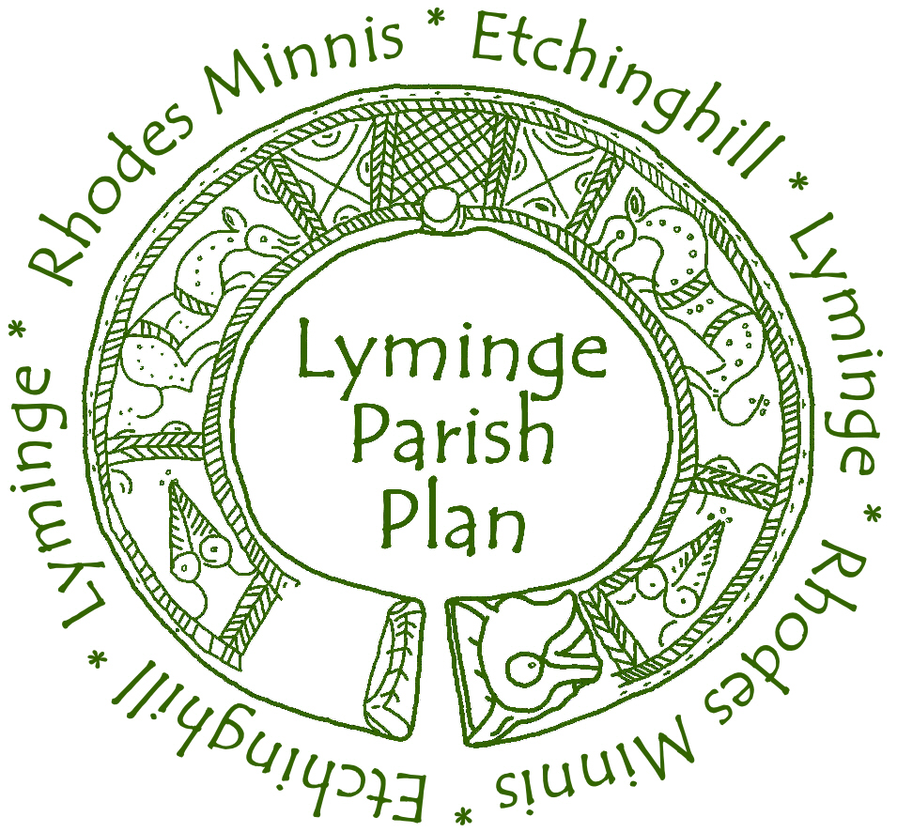
The Questionnaire
Lyminge Parish Council has helped to establish the Lyminge Parish Plan Group to produce a plan for the future of our locality based on the wishes of our community. You may have taken part in our previous activities. Now we are reaching the most important part – The Questionnaire. It is based on the concerns you raised previously through our projects. It is very important that your household completes this as it is your main opportunity to provide information. The result will be that an action plan for the future of our parish can be prepared. It should only take about 20 minutes for each person to complete. It is confidential and cannot be traced back to you.

The Questionnaire is divided into two parts:

PART A -To be completed by one adult member of your household

PART B -To be completed by all members of your household (aged over 11 years). We are involving children in this as their future is important. If they need help, please could an adult guide them.
Throughout this questionnaire you will find help about completing the form written in italics like this.

If you have any queries about completing this questionnaire please do not hesitate to contact one of the Parish Plan Group members listed below:

Mike Foxon - Lyminge - 862073
Les Preston - Etchinghill - 863495
Alistair Bailey - Etchinghill – 864235
Charlie Dodds – Lyminge – 862800
If you make a mess of your questionnaire or require one in large print then further copies can be down-loaded from our website www.lymingeparishplan.org.uk or obtained from our secretary, Les Preston (863495).

When your household has completed the questionnaire put it in the envelope provided and post it by Thursday 31st March. If you lose your envelope the return address is: Lyminge Parish Plan
Channel Business Centre
Ingles Manor, Castle Hill Avenue
Folkestone
Kent
CT20 2RD
A report will be written from all your responses which will be published later in the year and a summary will be sent to all households in Lyminge Parish.

Thank you for your help.

PART A. - TO BE COMPLETED BY 1 ADULT PERSON FROM YOUR HOUSEHOLD.
Place one tick (√ ) in the box of your choice unless asked otherwise.

General Location

A1. Where is your home located?

Lyminge
Etchinghill
Rhodes Minnis
Outlying areas

Your Household & your home

A2. Please enter, in each age group, the number of people in your household.

Age | Male | Female
0-4
5-10
11-15
16-17
18-24
25-44
45-59
60-64
65-74
75-84
85+

A3. Enter the number of children under 16 in your household who attend the following in or outside the parish:
IP = in Lyminge Parish
OP = outside Lyminge Parish
 | IP | OP
Mothers & Toddlers
Pre-School
Primary School
Secondary School
Special Needs School
Other – state below
Comments:

A4. Has any member of your household permanently moved out of the Parish in the last 5 years?

Yes
No
Comment (e.g. why anyone has moved.):

A5. How many road-worthy vehicles are kept by your household?

Enter number in the box | Number
Bicycles
Cars
Vans
Motor bikes
Specially adapted vehicles
Lorries

A6. Do you have any flooding problems or regular storm damage?

Many problems
Few problems
No problems

If you have a problem please describe it and the general location:

PART B - PERSONAL SECTION - FOR EVERY MEMBER OF THE HOUSEHOLD WHO IS 11 YEARS OR OVER TO COMPLETE.
The person who completed PART A can be person 1 and then each other household member can be ‘Person 2’, ‘Person 3’ etc.
Place one tick (√ ) in the box of your choice unless asked otherwise.

People

B1. Are you male or female?

Person | 1 | 2 | 3 | 4 | 5 | 6
Male
Female

B2. In what age group are you?

Person | 1 | 2 | 3 | 4 | 5 | 6
11-15
16-17
18-24
25-44
45-59
60-64
65-74
75-84
85+

B3. How long have you lived in the Parish?

Person | 1 | 2 | 3 | 4 | 5 | 6
Less than a year
1-5 years
6-15 years
16-25 years
26-50 years
51+ years
Whole life

B4. What is your main occupation?

Person | 1 | 2 | 3 | 4 | 5 | 6
Professional
Clerical
Skilled Manual
Manual
Shop work
School/College
Home Maker
Retired
Unemployed
Other – state below

B5. Where is your main place of occupation, school or college?
(e.g. Dover, Etchinghill, At Home)

1

2

3

4

5

6

Transport and Highways

B6. If you travel to work, school or college what is your main means of transport?
Person | 1 | 2 | 3 | 4 | 5 | 6
Walk
Bus
Car
Motor Bike
Bicycle
Train
Taxi/Private Hire

B7. How often do you use the following services?
Enter code:
a – most days
b – about once a week
c – about once a month
d – a few times a year
e - never
Person | 1 | 2 | 3 | 4 | 5 | 6
Stagecoach Bus
Poynters Bus
Supermarket Bus
Train
Taxi/Private Hire

B8. Indicate any improvements in the public transport services you would like to see:
Tick (√ ) more than 1 box if relevant.
Person | 1 | 2 | 3 | 4 | 5 | 6
Bus shelters
Routes
Timetable
Fares
Reliability
Location of bus-stops
Disability access
Improved Taxi service
No opinion
Comments (e.g. location etc):

B9. Do you think there are any major ’danger spots’ on the roads in the Parish?
Person | 1 | 2 | 3 | 4 | 5 | 6
Yes
No
No opinion
B10. If you answered ‘Yes’, where are the danger spots?
Person
1

2

3

4

5

6
B11. Would you support any of the traffic calming measures below?
Enter a letter according to importance:
a = High importance
b = Medium importance
c – Low importance
d = No importance
Person | 1 | 2 | 3 | 4 | 5 | 6
New speed limit zones
Extension of speed limit zones
Road humps
Extension to ‘No Parking’ zones
Increased ‘On Road’ Parking
‘Gated’ entrances to settlements
Traffic Lights
Zebra Crossing
Flashing speed indicator board
Frequent Police speed checks
Other – Please state

Comments (e.g. where traffic calming should be):
Person
1

2

3

4

5

6

B12. If you drive, do you have problems parking near the shops or library in central Lyminge?

Person | 1 | 2 | 3 | 4 | 5 | 6
Often
Occasionally
Never
Comments:
B13. Do you experience the following parking problems near your home?
Person | 1 | 2 | 3 | 4 | 5 | 6
Cars parking on
the pavement
Commercial
vehicle parking
Nowhere to park
Cars blocking
your entrance
No problems
Please identify where any parking problem is:

B14. In relation to paths and streetlights, would you like to see any of the following in the parish?
Tick (√ ) more than 1 box if relevant
Person | 1 | 2 | 3 | 4 | 5 | 6
Cycle paths
More pavements
More street lights
More footpaths
Pelican crossings
Dropped kerbs
Traffic islands
None of the above
B15. If you feel any of the features in the previous question are required please indicate where in the parish they might be sited.
Person
1

2

3

4

5

6
Community Services
B16. What are your views on the response or availability of the following services to the Parish?
Enter code:
a – good
b – reasonable
c – poor
d – have not used service
Person | 1 | 2 | 3 | 4 | 5 | 6
Fire
Ambulance
Hospital transport
Police (Emergency)
Community Police
Community warden
Comments

B17. Which, if any, of the following crimes and anti-social behaviour concern you in this Parish?
Tick (√ ) more than one box if relevant.
Person | 1 | 2 | 3 | 4 | 5 | 6
Burglary/Theft
Mugging
Vandalism
Drunkenness
Littering
No concerns
Other - state below
Comments

B18. Would you like to join the Neighbourhood Watch Scheme?

Person | 1 | 2 | 3 | 4 | 5 | 6
Yes
No
Already in it
B19. What are your views on the standard of these environmental services in the Parish?
Enter code: a – good
b – reasonable
c – poor
d – no opinion
Person | 1 | 2 | 3 | 4 | 5 | 6
Street cleaning
Drain clearing
Street lighting
Water supply
Gas supply
Electric supply
Refuse collection
Recycling service
Recycling site
Public Toilets
Road Gritting
Grass cutting
Flower displays
Litter bin emptying

Retail Services and Other Facilities

B20. If you usually shop in the Parish is it because…
(If you do not shop in the parish please go to next question.)
Tick (√ ) more than one box if relevant
Person | 1 | 2 | 3 | 4 | 5 | 6
The local shops give good value
You like to support local shops
You like the social contact
It saves time
It saves transport costs
You don’t have transport to go elsewhere
You need ‘last minute’ items
Other – state below
Comments:

B21. If you usually shop out of the Parish, is it because…
Tick (√ ) more than one box if relevant
Person | 1 | 2 | 3 | 4 | 5 | 6
Goods are cheaper
You have more choice there
It is convenient to your place of work
Easier to park
Other – state below
Comments

B22. If you use the Lyminge Post Office, please say what for…
Tick (√ ) more than one box if relevant
Person | 1 | 2 | 3 | 4 | 5 | 6
Postal services
Pensions
Child Benefit
Tax Credits
Banking/cash
Currency exchange
Vehicle Tax
Bill payments
Insurance
Passports
Non Post Office goods
Don’t use
Other – state below
Comments:

You have passed the half way point.
Religion
B23. Are the local churches important to you for any of the following reasons?
Tick (√ ) more than one box if relevant
Person | 1 | 2 | 3 | 4 | 5 | 6
For worship
For private prayer
For baptisms weddings and funerals
For pastoral support
To visit graves / war memorial
As a focal point for the community
As historic buildings
Every place should have one
To use the grounds as a public space
Other – state below
No importance
Comments:

Leisure facilities
B24. How do you rate the following leisure facilities in the parish?
Enter code: a – good
b –reasonable
c – poor
d – not used this facility
Person | 1 | 2 | 3 | 4 | 5 | 6
Community Halls
Library
Public Houses
Lyminge Forest
Children’s Play Areas
Tayne Field
Sports Facilities
Other – state below
Comments (if poor state where and why):
B25. If funding was available, does the Parish need any of the following sports facilities?
Enter a letter according to priority:
a = High Priority
b = Medium Priority
c – Low Priority
d = No Priority
Person | 1 | 2 | 3 | 4 | 5 | 6
Multi-sports court
Tennis court
Petanque / Boules pitch
Indoor sports centre
Skateboard park
Swimming pool
Other – state below
Comments (e.g. Where?):

B26. Which new SPORTS clubs/activities would you (or your children under 11 years) take part in or help organise in the Parish?
Person
1

2

3

4

5

6

B27. Which new SOCIAL clubs/activities would you (or your children under 11 years) attend in the Parish if they were provided?
Person
1

2

3

4

5

6

B28. Do you think the halls in the parish are adequate for the needs of the community?
Enter code: a – yes
b –no
c – no opinion
Person | 1 | 2 | 3 | 4 | 5 | 6
Lyminge Village Hall
Etchinghill Village Hall
Rhodes Minnis Village Hall
Lyminge Methodist Church Hall
Comments (e.g. if you answered ‘No’ state why?):

Information & Communication
B29. About what subjects would you like to receive regular information?
Tick (√ ) more than one box if relevant
Person | 1 | 2 | 3 | 4 | 5 | 6
Parish Council activities
Planning applications
Local interest
Local Heritage
Local Environment
Leisure
Local Arts
Local Sports
Other – state below
Comments:

B30. Do you have any reception difficulties with the following?
Tick (√ ) more than one box if relevant
Person | 1 | 2 | 3 | 4 | 5 | 6
Radio
Digital radio
Terrestrial TV
Free view TV
Digital TV
Satellite TV
Mobile Phone
Broad Band
Comments:

You’re two-thirds of the way through.
B31. In relation to information services, do you think that the parish needs any of the following?
Tick (√ ) more than one box if relevant
Person | 1 | 2 | 3 | 4 | 5 | 6
Notice boards
Tourist information points
Maps
Signposts
Brown Tourist signs
Other – state below
Comments (e.g. where any of these should be sited):

Education

B32. Do you think the parish needs any of these additional educational facilities?
Tick (√ ) more than one box if relevant
Person | 1 | 2 | 3 | 4 | 5 | 6
Mother & Toddlers
Pre-School
Childminders
Full day Childcare
After School clubs
Holiday play scheme
Adult Education
Other – state below
Comments:
Local Government
B33. How well does the local council publicise its decisions and activities?
Person | 1 | 2 | 3 | 4 | 5 | 6
Very well
Reasonably well
Poorly
No opinion
Comments (e.g. any additional information you feel is needed):

B34. How do you hear about local council decisions and activities?

Person | 1 | 2 | 3 | 4 | 5 | 6
Notice board
Council Newsletter
Word of Mouth
I don’t hear about them
Other
Comments:

B35. Would you be prepared to pay a slightly higher council tax to meet some of the additional agreed needs of the parish?

Person | 1 | 2 | 3 | 4 | 5 | 6
Yes
No
No opinion
Comments:

Health and Social Services

B36. If you have used any of the following services which cover the Parish during the last year, how do you feel with the service provided?
Enter code: a – it was good
b – it was reasonable
c – it was poor
d – not used this service
Person | 1 | 2 | 3 | 4 | 5 | 6
Social care
Inc. Home help
Dentist surgery
Doctor’s surgery
District Nurse
Health Visitor
Maternity care
Chiropody service
Physiotherapy services
Occupational Therapy provider
Alternative Treatment provider
Counselling service
Loan of medical equipment

B37. Do you think NHS services are adequate in the locality?
Person | 1 | 2 | 3 | 4 | 5 | 6
Yes
No
No opinion
Comments (e.g. if you feel the services are inadequate or may be so in the future please explain):

Environment
B38. What do you think should be done to help protect and enhance the local environment of the Parish?
Enter a letter according to priority:
a = High Priority
b = Medium Priority
c – Low Priority
d = No Priority
Person | 1 | 2 | 3 | 4 | 5 | 6
Improved doorstop recycling
Improved recycling sites
Energy saving
Improved public transport
Car sharing
‘Walking Bus’
Other – state below
Comments:
B39. Do you experience any of the following difficulties when using local footpaths, byways and bridleways?
Tick (√ ) more than one box if relevant
Person | 1 | 2 | 3 | 4 | 5 | 6
Obstructions
Animals
High stiles
Mud/Water
Crops across path
Other users
Bushes/nettles
No signposts
Crossing roads
Other – state below
No difficulties
If you indicated difficulties please state where they are:
Housing/Business development

B40. Would you like to see further housing development in the Parish?

Person | 1 | 2 | 3 | 4 | 5 | 6
Yes
No
No opinion

If you answered ‘No’ or ‘No Opinion’ go to B44.

B41. Which types of housing development would you support in the Parish?
Tick (√ ) more than one box if relevant
Person | 1 | 2 | 3 | 4 | 5 | 6
Homes for young couples
Large family homes
Small family homes
Executive homes
Homes for people with disabilities
Homes for single people
Other – state below
Comments:

B42. What type of housing development would be acceptable in Lyminge Parish?
Tick (√ ) more than one box if relevant
Person | 1 | 2 | 3 | 4 | 5 | 6
Single Dwellings in controlled locations
Small group(s) of less than 10
Carefully designed larger groups
Conversion of redundant buildings
Expansion on the edge of settlements
Other – state below
Comments: (e.g. where any of these developments could happen.)
B43. Is there need for more accommodation of the following types in Lyminge Parish?
Tick (√ ) more than one box if relevant
Person | 1 | 2 | 3 | 4 | 5 | 6
Private rented
Local authority / housing association rented
Owner occupied
Shared ownership
By virtue of employment (e.g. MOD/tied)
Sheltered housing
Adapted housing
Restricted sale to local people
Low cost sale
Other – state below
Comments:

B44. Would you like to see further business development in the Parish?

Person | 1 | 2 | 3 | 4 | 5 | 6
Yes
No
No opinion

If you answered ‘No’ or ‘No Opinion’ go to B46.

B45. Which types of business development would you support in the Parish?
Tick (√ ) more than one box if relevant
Person | 1 | 2 | 3 | 4 | 5 | 6
Shops and small businesses
Tourism
New Public Houses
Guest house/hotels
Conversion of redundant buildings
Light industrial
Workshops
Sheltered Workshops
Comments (e.g. types of business that might be established.):

Only a little way to go now.
General
B46. Some of the local settlements currently lie in two parishes (e.g. Rhodes Minnis, Farthing Common, New Barn, Yew Tree Cross, Six Mile). If the parish boundary could be changed would this be an improvement?
Person | 1 | 2 | 3 | 4 | 5 | 6
Yes
No
No opinion
Comments:

B47. What do you view as the most important physical features of Lyminge Parish? (e.g. specific buildings, structures or natural features)
Person
1

2

3

4

5

6

B48. What do you view as the most important single issue for the future of Lyminge Parish?
Person
1

2

3

4

5

6

That’s it! You’ve finished. Thank you.
ONCE THE LAST MEMBER OF THE HOUSEHOLD HAS COMPLETED THE QUESTIONNAIRE PUT IT IN THE ENVELOPE PROVIDED & POST IT BY THURSDAY 31st MARCH.
If you have lost your envelope the return address is:
Lyminge Parish Plan,
Channel Business Centre
Ingles Manor,
Castle Hill Avenue,
Folkestone
Kent.
CT20 2RD.

